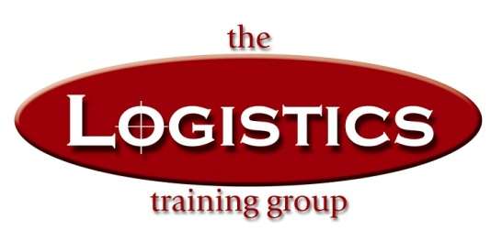
CILT UK PROFESSIONAL DIPLOMA IN LOGISTICS & TRANSPORT
QUICK REFERENCE SHEET
STUDY AREAS (Military & Civilian)
Specialist Management Studies in - Logistics; Supply Chain; Warehousing; Inventory; Value Chain; Multi-Modal Transport; Marketing; Production; Sourcing/Procurement; SC Flow & Network Planning; International Business; SC Retail Logistics; Information & Communication Technology in the SC (ICT);
QUALIFICATION
PROFESSIONAL DIPLOMA IN LOGISTICS AND TRANSPORT
A UK Chartered Institute of Logistics & Transport (CILTUK) Qualification
Information Guide
COURSE SUITABILITY
This course is suited to frontline, middle and senior managers with functional responsibility for logistics and supply chain management activities in a range of industries; military officers in logistics and supply chain roles; graduates entering the logistics profession; and individuals involved in contributing to logistics strategy, establishing activity plans and reviewing operations.
ENTRY REQUIREMENTS
This is a bridging course between experience and academia. Therefore prior experience and education are looked at on an individual basis. However a general guide is a minimum of 3 years managerial logistics experience, with good basic maths, report writing, word and excel skills. Before enrolment students should be prepared to submit their current CV and undergo a telephone interview.
ENROLMENT
After the enrolment form has been received applicants will be notified re acceptance status if not previously accepted for the course.
Application for Enrolment Form
DELIVERY
A combination of self paced learning, electronically submitted assignments, and face to face block courses for the Supply Chain Management and Core Management modules. Block course attendances are very strongly advised. It is part time, distance study with the support of high level industry coach/assessors throughout the 4 modules.
Block Courses:
SCM - 2 x 2days:
Core Management – 1 x 2days.

WORKLOAD
4 - 10 hours per week.
Assessment is by a number of practical assignments and a workplace based project which are all submitted electronically.
CANDITATURE
Two years with a maximum time limit of three years.
FACILITATOR
Walter Glass
COST
LTG - Professional Diploma Course Costs
UK Assessment & Registration Costs for Professional Diploma Course
BENEFITS
Benefits have been determined by the Chartered Institute of Logistics and Transport, United Kingdom (CILT UK). These are the recommended skills identified to gain employment, establish an enterprise, for career progression, to expand employment capability and to achieve individual potential and contribute to organisational strategic outcomes. Training Packages have been reviewed to ensure that Employability Skills feature in their units of competency. These also include - Communication - Teamwork - Problem Solving - Initiative & Enterprise - Planning & Organising - Self Management - Learning - Technology.
SKILLS OUTCOME
On successful completion of this course participants will have the skills to:
Recruit appropriate personnel and implement effective people management strategies
Implement a business plan
Plan and analyse supply chain strategies to meet customer service requirements
Cost operations, benchmark performance and evaluate suitability of benchmarks
Conduct and evaluate a supply chain audit and devise suitable improvement strategies

ASSESSMENT
Students are assessed through regular assignments and completing a work-based project.
LEARNING PATHWAYS
The Professional Diploma in Logistics & Transport is recognised as an alternate experience-based pathway to the academic postgraduate diploma at Massey University, New Zealand, and as a bridging program to the Masters in Logistics and Supply Chain Management. Graduates are eligible to apply to enrol in the Masters program at Massey University. Pathway diagram
COURSE MODULES
There are Four Modules to be completed for the qualification
TWO COMPULSORY MODULES
Supply Chain Management
Core Management

Compulsory Module Components
TWO TECHNICAL MODULES: from 9 elective options
Select two elective modules from the following
1 Inventory
2 Production Planning
3 Warehousing
4 International Business
5 Sourcing
6 Movement of Goods (Transport)
7 Retail Supply Chain Logistics
8 Supply Chain Network Planning
9 Supply Chain Flow Planning

Elective Module Components

